Project Proposal



Section:
04
Course:
ITP

Submitted to:
Dr. Syed Saqib Raza Rizvi

Submitted by:
Raja Muhammad Hashir Amjad
{BCS253060}
Department of Computer Science
 Capital University of Science &Technology

CUST 2026
Code:
#include <iostream>
#include <fstream>
using namespace std;
struct Finance
{
int id;
char name[50];
double salary;
};
// Function to search employee by ID
void searchEmployee(Finance emp[], int n)
{
int searchId;
cout << "\nEnter ID to search: ";
cin >> searchId;
for (int i = 0; i < n; i++)
{
if (emp[i].id == searchId)
{
cout << "\nEmployee Found!\n";
cout << "ID: " << emp[i].id << endl;
cout << "Name: " << emp[i].name << endl;
cout << "Salary: " << emp[i].salary << endl;
return;
}
}
cout << "\nEmployee not found.\n";
}
int main()
{
int n;
Finance emp[100];
cout << "Enter number of finance employees: ";
cin >> n;
for (int i = 0; i < n; i++)
{
cout << "\nEnter details of employee " << i + 1 << endl;

cout << "Enter ID: ";
cin >> emp[i].id;
cin.ignore();

cout << "Enter Name: ";
cin.getline(emp[i].name, 50);

cout << "Enter Salary: ";
cin >> emp[i].salary;
}
cout << "\nEmployee List:\n";
for (int i = 0; i < n; i++)
{
cout << "ID: " << emp[i].id << endl;
cout << "Name: " << emp[i].name << endl;
cout << "Salary: " << emp[i].salary << endl << endl;
}
// Call search function
searchEmployee(emp, n);
// Save in file
ofstream file("Finance.txt");
for (int i = 0; i < n; i++)
{
file << "ID: " << emp[i].id << endl;
file << "Name: " << emp[i].name << endl;
file << "Salary: " << emp[i].salary << endl << endl;
}
file.close();
cout << "Data saved in Finance.txt";
return 0;
}
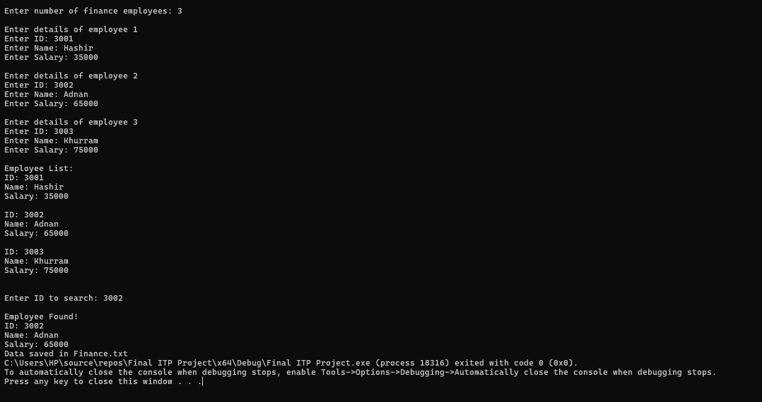

Explanation:
This program stores the details of finance employees using a structure that contains ID, name, and salary.
It takes input for multiple employees, displays their information on the screen, and saves the same data in a text file named Finance.txt.
A separate function is used to search an employee by entering their ID.
The search function checks each employee one by one and displays the details if a match is found.
If the entered ID does not exist, it shows a message that the employee is not found.
Overall, the program demonstrates basic use of structures, arrays, functions, loops, and file handling in C++.

Expected Output:

The program will ask for employee details, display all entered records, and then search for an employee using an ID. If the ID is found, the employee’s information will be shown; otherwise, a “not found” message will appear. Finally, it will save all the data in the file Finance.txt.

Thank You!

**********************

